_______________________________________

Hawthorn Parish Council

Business Plan :

2021 – 2025

_______________________________________

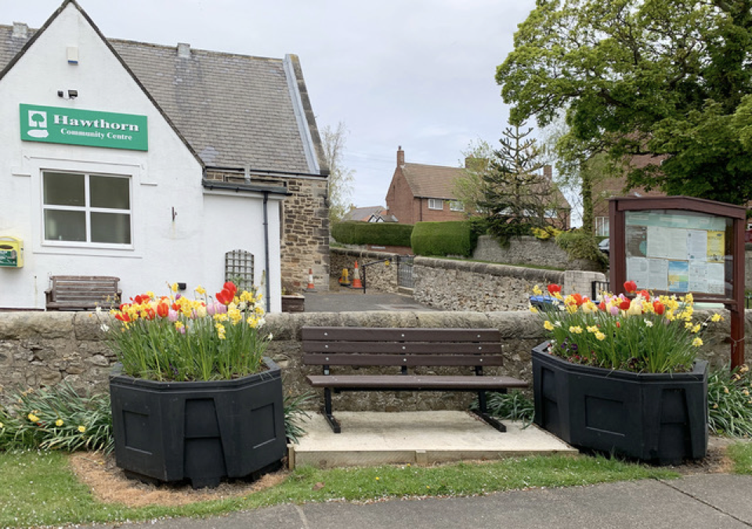

Contents

1. Introduction and aims 3
2. Why produce a Business Plan? 3
3. Overview of the Council 3
4. Hawthorn Parish Council Responsibilities 4
5. Councillors 5
6. Council Meetings 5
7. Council Management and Services 5
8. Financial Information 6
9. Parish Council Governance 6
10. A Focus for our Action Plan 6
11. Plan of Hawthorn 7
12. Hawthorn Budget Estimates 2020 /2021 7
13. Focus & Action Plan : Administration 10
14. Focus and Action Plan : The Local Environment 11
15. Focus and Action Plan : Community Engagement and Events 12

Introduction and aims

This is Hawthorn Parish Council’s Business Plan for the next four years.

It sets out the Parish Council’s vision, its purpose, values, objectives and key priorities.
The aim of the Plan is to give Hawthorn’s parishioners and residents a clear understanding of what their parish council does and what it is trying to achieve. It details what the Parish Council intends to focus on over the next three years and until the next parish council elections in 2025.

This business plan is a live document which will be reviewed annually, and which will be used to drive the budget process, plan activities and enable the parish council to monitor its progress against key priorities.

Why produce a Business Plan?
Having an agreed strategy provides a framework for the Parish Council to work within, enabling it to operate in a more consistent and coordinated way, and to be proactive rather than reactive in its decision-making.

The parish council elections take place in May 2021 place and the council will be at the beginning of its four-year term of office. It is, therefore, an ideal time to update the previous Plan of 2017 – 2021 and begin work on the 2021 – 2025 Plan. Moreover, a plan will underpin all grant and funding applications and furthermore enable the parish council to re-apply for Quality Gold Status which is the benchmark for all local councils and demonstrates to all that the council is efficient and effectively run.

At the same time the Business Plan will help the local community to have a better understanding of what the Parish Council does and also clarify what it doesn’t or is unable to do and what issues fall under the responsibility of the principal local authority - Durham County Council.

The Hawthorn Business Plan is a statement of intent. However, it will not be set in stone and will be subject to future budget constraints and future changes in legislation which affect all local authorities. Any changes will be reflected in an updated plan. This plan will be available for all residents and will be accessible on the Parish Council website.

Overview of the Council
There are two tiers of local government within Co. Durham, each with different roles:-
Hawthorn Parish Council is the first and most local tier, and with an important role to play in promoting Hawthorn and representing both the interests and work of its residents and organisations.

Durham County Council (DCC) is the second tier and is responsible for services such as education, highways, health, social services and environment as well as the strategic planning policies for all development including housing and employment sites via its Local Plan.

Hawthorn Parish Council Responsibilities

These include:-
Management and maintenance of the village green and open spaces Management and maintenance of the Glencot play area
Provision and maintenance of seats and benches Provision of community grants
Provision of dog poo bags
Submitting comments on all planning applications
Funding and delivery of parish events and support and facilitation of groups providing parish events i.e.
- Christmas Tree and Lights
- Carols around the Tree
- Snowman Competition
- Best Dressed House (Christmas Decorations)
- Sunflower Competition
- Big Lunch
- Open Garden Walk
- Community Bulb Planting
- Flowerpot Festival
- Photograph Exhibition
- Hawthorn Dene Walk
and support for the Trail Run, Litter-pick etc.
The Council represents the parish on a number of external organisations including:-
    - Hawthorn Community Centre
    - East Durham Local Council Committee
    - East Durham AAP
    - County Durham Association Small Councils Committee

The Council also looks to reflect the views of our community by liaising with other public bodies and commenting on key strategic issues such as housing, highways, planning etc.

Moreover, the parish council considers community engagement to be of paramount importance and ensures all residents are kept fully informed of all decisions and proposals that may affect them. This is done via
    - The monthly electronic newsletter - the Hawthorn Round Up
    - A quarterly newsletter delivered to all residents
    - The council website at www.hawthornparish.co.uk

Councillors
Residents elect seven parish Councillors every four years - the next election will be May 2021. The Council then elect the Chairman and Vice Chairman of the Parish Council each year at the Annual Meeting of the Council which is held each year in May.
Hawthorn Parish Councillors are not paid.

Council Meetings
Hawthorn Parish Council meets each month ( except August) on the third Monday. The agenda for each meeting is posted on each of the two notice boards and on the Parish Council website with a minimum of 3 clear days’ notice, although in practice seven days is usually given. There is a time for public participation at each meeting when all residents are able to give their views and comments.

In addition to the monthly meetings and the annual meeting of the council , there is also the ‘Annual Parish Meeting’ which is generally held in March. This is the opportunity for all residents to come along and hear what the parish council has done over the previous year, ask questions and also hear reports from the Police, County Councillors, Community Association and any other groups and organisations.

The Council works to its Standing Orders and Financial Regulations and which lay down the rules by which the council is expected to operate and conduct its business. In addition, the council has a number of adopted policies and protocols which ensure meetings operate efficiently and effectively. All of these are available on the website.

Council Management and Services
Hawthorn Parish Council is responsible for several open spaces including the play area and village green. In addition, it organizes a number of community events and works closely with the community association which now manages the community centre.

The Council employs one part-time officer - the Parish Clerk. The Parish Clerk administers the council and carries out all of the council’s decisions. The Clerk is the Parish Council’s ‘Proper Officer’ - a statutory requirement of all parish councils is to employ this person.

The Hawthorn Parish Clerk also administers the council website and electronic and written newsletters. The Clerk is also the council’s Responsible Financial Officer and is responsible for ensuring the annual return and audit are prepared for acceptance by the council. It should be noted that hawthorn Parish Council was one of the first paperless councils in the country and only the minute book and annual returns are now in hard copy.

All other work i.e., grass cutting, seat maintenance, play equipment inspections etc is undertaken by contractors.
The council also relies on volunteers who help out at various village events.

Financial Information
Hawthorn Parish Council is funded directly through a precept collected via the Council Tax on the residents of Hawthorn. The precept for 2020 /2021 is £8,509, representing a Band D Council Tax of £42.25 per year. ( In this document we tell you what you can expect to get for your money, and you can decide whether or not it represents good value for money.)

The expenditure for the Parish Council includes the salary of the Parish Clerk, grants and donations to local groups, local events, general maintenance of the open spaces and play area and additional capital projects and equipment. These include the defibrillator, smart TV and wireless internet in the community centre, together with the new laptop, printer and scanner for the council. These new items have been funded from successful grant applications.

Further successful grant applications were made in 2017 and 2019 to Awards for All for £10,000 and £8,500 for a ‘Community Plant’ Project which included a new community greenhouse, self-watering planters, extensive bulb planting and new seats and benches, and a ‘Keeping the Community in the Know’ which included new solar powered noticeboards.

Full details of all transactions, income and budgets and estimates are on the website.

Parish Council Governance
Hawthorn Parish Council aims to be a professional, competent and caring Parish Council, to be open and accountable in all it does and to ensure sound financial management of Parish Council resources.

The Parish Council aims to:
Be well informed about the needs and opinions of our residents by consulting them on major issues Improve services to the public by encouraging Councillors and Clerk to develop their skills by undertaking appropriate training
Ensure we give Councillors the opportunity to keep abreast of new opportunities and policy Be a good and fair employer
Continuously promotes public participation in all Parish Council meetings and initiatives Deal with enquiries and fault reports from members of the public speedily and efficiently Be an effective custodian of the Council’s property and documents

A Focus for our Action Plan
The Parish Council has identified key priorities which we wish to concentrate on over the next three years. These form the basis of the Focus for our Actions Plan.
The major objectives are further broken down into Action Items and projects which are then defined more fully as resources become available .

The Business Plan can be viewed in detail at www.hawthornparish.co.uk

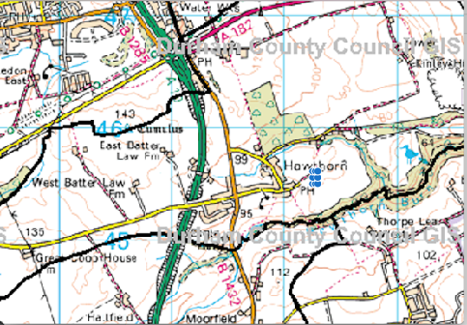
Plan of Hawthorn

Hawthorn Budget Estimates 2020 /2021

Income | 2018/2019 | 2019 / 20 | 1/2 year | est year end | 2020/2021
Balance carried forward | £7,554 | £7,564 | £7,564 | £7,084 | £7,084
Income
Precept | £8,606 | £8,672 | £8,672 | £8,672 | £8,500
LCTRS | £29 | £0 | £0 | £0 | £272
Vat Prev Year | £586 | £500 | £0 | £500 | £500
Bank Interest | £19 | £18 | £0 | £18 | £18
Grants | £150
Total Income | £9,390 | £9,190 | £8,672 | £9,190 | £9,290

Council Tax Calculation
Precept | £8,606 | £8,672 |  |  | £8,500
Tax Base | 204 | 206 |  |  | 201
Band D (Precept / Tax base) | £42 | £42.10 |  |  | £42.29

Expenditure | 2018/2019 | 2019 / 20 | 1/2 year | est year end | 2020/2021
General Administration
Clerk's salary | £2,577 | £2,635 | £1,280 | £2,560 | £2,600
Postage, telephone, admin etc. | £120 | £120 | £104 | £140 | £140
Travel expenses | £532 | £520 | £0 | £530 | £530
Insurance | £444 | £450 | £450 | £450 | £450
Internal audit | £100 | £100 | £100 | £100 | £100
Honours Board | £0 | £0 | £65 | £65 | £0
FOI Commissioner | £30 | £30 | £0 | £34 | £35
Hire of Hall | £220 | £250 | £0 | £240 | £220
Elections | £0 | £200 | £0 | £0 | £200
Quality Gold App | £60
Total Administration | £4,083 | £4,305 | £1,999 | £4,119 | £4,275
Community Engagement
Website /e mail | £72 | £120 | £120 | £120 | £125
Newsletter / Printing | £180 | £180 | £150 | £200 | £200
Total Community Engagement | £252 | £300 | £270 | £806 | £325
Training /Subscriptions
Chairman's Allowance | £25 | £75 | £25 | £50 | £75
Cllr. Training | £75 | £150 | £54 | £71 | £120
Subscriptions | £230 | £240 | £150 | £240 | £245
Total Training / Subs | £330 | £465 | £229 | £361 | £440
Grants
Donations | £400 | £400 | £300 | £400 | £400
Total | £400 | £400 | £300 | £400 | £400
Open Spaces
Grasscutting | £1,750 | £1,800 | £0 | £1,850 | £1,850
Play Area inspections | £300 | £300 | £0 | £300 | £300
General Open Spaces | £500 | £500 | £200 | £800 | £800
Dog Bags | £270 | £130 | £244 | £244 | £0
Trees | £150 | £50 | £0 | £100 | £100
Total Open Spaces | £2,970 | £2,780 | £444 | £3,294 | £3,050
Events
Christmas Tree and Lights event | £550 | £550 | £0 | £550 | £550
Sunflower | £70 | £70 | £50 | £50 | £50
Bulb Planting | £0 | £0 | £0 | £0 | £0
Snowman Competition | £50 | £50 | £0 | £50 | £0
Big Lunch / Open Garden Walk | £270 | £270 | £40 | £40 | £200
Total Events | £940 | £940 | £90 | £690 | £800
Capital
Community Centre | £520 | £0 | £486 | £486 | £0
Total Capital | £520 | £0 | £486 | £486 | £0
TOTAL Expenditure | £9,095 | £9,190 | £3,818 | £9,670 | £9,290

Focus & Action Plan : Administration

Focus : | Administering the Council
- Aims | - Objectives | - Implication | - Timescale
To ensure all HPC’s policies and protocols are adhered to and updated as and when necessary | To continue operating to standing orders & financial regs | Already included in working practices | Ongoing
Review of the action and business plans | To continue to review on a regular basis and also add to the website | Improve transparency | Ongoing
To adhere to all new legislation | To ensure website accessibility | The Clerk continues to work to ensure compliance in line with regulations as applicable to a very small parish council. | Ongoing
To continue monitoring estimates and budgets | To continue to review on a quarterly basis | Ensure ongoing transparency | Ongoing
To maximise grant opportunities | To continue to seek all relevant grant opportunities | Successful applications will provide additional capital schemes which otherwise would not be possible | Ongoing
Insurance | To obtain new quotes and accept as appropriate | The Clerk to undertake every 3 years | Ongoing
Planning | Continue and improve participation in planning matters | Ensure local feelings are taken into account. | Ongoing
Transparency Code | To ensure compliance | Statutory requirement | Ongoing
To keep under review legal powers and opportunities | Ensure compliance | Statutory requirement | Ongoing
Contingency Plan | To create | Ensure arrangements if need arises | April 2021  Delayed due to pandemic)
Councillor Training | To encourage all Councillors to take advantage of all training available | To ensure Cllr are fully knowledgeable.  Training included in Budgets | Ongoing
Clerk : Training | To encourage the Clerk to take advantage of all relevant training | To ensure the Clerk is fully knowledgeable and up to date with all relevant information Training included in Budgets | Ongoing
Protecting the Parish | The council will continue to have close liaison with the Police and Ward members | To ensure communication both ways | Ongoing

Focus and Action Plan : The Local Environment

Focus : | The Local Environment
- Aims | - Objectives | - Implication | - Timescale
To continue to improve the local environment  Courtesy of £10,000 Grant from Awards4All in 2018 | To purchase more spring bulbs and hold the Community bulb planting event again in October | £500 from grant remaining for bulbs | Completed
 | To purchase 2 more new seats | £1200 from grant remaining
 | To consider new planters – and planting | £500 from grant remaining
 | To provide new shelving for the new community greenhouse | £750 from grant remaining
 | To purchase new bushes /trees | £250 from grant remaining
Open Spaces and Greens | To continue to ensure all greens and open spaces are well cared for | In budgets | Ongoing
To tackle litter and dog fouling | - To monitor adequacy and position of litter and dog poo bins  - To review providing free dog poo bags  To organise / support litter picks – including the Spring Clean Initiative | Budget implications  Additional litter bins at £450 each plus installation  Dog poo bags £100  New dog signs for Dene | Ongoing
To urge DCC to review Speed limit on Stockton Road | To work with DCC | No financial implication, currently pursuing options | Ongoing

Focus and Action Plan : Community Engagement and Events

Focus : | Community Engagement & Events
- Aims | - Objectives | - Implication | - Time
To improve Communication | To continue to develop all means of consultation / communication | In budgets | Ongoing
To commence the ‘Keeping you in the know’ Project | To purchase the:  - New solar noticeboards  - lectern information board  - Banners | As per £8,600 received from Awards 4All | 2021
To ensure all residents are fully informed | To continue the electronic Hawthorn Community, Round up and aim to deliver to 80% of local residents | No additional cost | Continual monitoring
 | To continue to produce 4 x Newsletters each year.  Summer to be AS in colour | In budget | Ongoing
Working with the Community Association for the Community Centre | To aid the Community Association to provide facilities including  - New smart TV  - New security lights – ongoing | Tv cost via Community Grant  Security Lights £450 – included in budget 2019 / 2020 | Ongoing
To provide Community Events | To hold:-  Christmas Events  - Christmas tree / lights  - Carols around the Tree  - Switch on event  - Snowman Competition | Annual Cost | Oct 2020 –
 | To hold Big Lunch Day Events  - Open Garden walk  - Flowerpot Exhibition  - Photographic Exhibition  - Treasure Trail | Annual Costs of £250 in budgets | Oct 2020 :
 | To hold  - Annual Sunflower Competition | Annual cost of £50 in budgets | Oct 2021
 | To hold  - VE Day Celebrations | Courtesy of grant of £960 from the Community Fund | 2021
 | To hold  - Hawthorn Spring Clean | No cost – all equipment provided by DCC | Ongoing
 | To hold  - Open walk around Hawthorn Dene | No cost | Ongoing
 | To work with Church  - Remembrance Day | Poppy wreath £25 | Ongoing
To re-introduce Neighbourhood Watch Scheme | To publicize and launch new scheme at Annual Parish Meeting | No financial implication | 2021

