The March Monthly Meeting of the Hawthorn Parish Council was held at 7pm on Monday 20th March 2023, in the Community Centre.

MINUTES

Present
Cllr Diane Hughes (Chairman)
Cllr. Sheila Irving (Vice – Chairman)
Cllrs Alan Askew, Sheila Wilson, Gary Thompson, Carolyn Winter

Officer: Lesley Swinbank (Parish Clerk)

2 Members of the Public:

Notice of Meeting
Public Notice of the Meeting has been given in accordance with Sch 12 paragraph 10(2) of the LGA 1972

Apologies
Cllr. Maxine Smith

Declarations of Interest
None

Minutes:
RESOLVED
To approve the Minutes of the Monthly Meeting held Monday 20th February 2023

Matters of Information: As per attached information sheet
All on agenda

Reports

Police

None

DCC
None

Community Centre
Given earlier at the Annual Parish Meeting.

Trees: Village green
A report was given on the recent pruning of the trees on the village green
RESOLVED
To seek another quote for pruning the other 2 trees.

Any other reports

CDALC
The Clerk reported that Steve Ragg has now retired from CDALC. A presentation had been made following the recent Civility Training Event. The Clerk had forwarded the Council’s best wishes.

Public Participation

Stockton Road: Litter picking
A resident commented on issues re the picking of litter on Stockton Road – and in particular litter close to the hedge – which does not appear to be picked up.
This will be discussed further at item 8.2.

Trees Village Green
A resident commented on issues of leaves falling on the village green.

Correspondence

Information Back Lane
Information re ownership and drainage on LAND OWNED BY DCC ON THE back lane has been received.
RESOLVED
To receive the information

Litter: E. Hubbuck
Concerns have been expressed about the litter picking by DCC along Stockton Road. This includes the shrub / hedging on the eastern side of Stockton Road, where rubbish often accumulates. In addition, it was suggested these shrubs should be pruned back – which would help the overall litter situation.
RESOLVED
To forward concerns to DCC together with suggestions as how this area can be improved.

Land: Open Space
DCC have now confirmed that the area of grass verge opposite the church is not common land or village green, but that DCC have maintained this since the local government re-organization in 2009.
RESOLVED
To receive the information and await further information from DCC’s Asset Management Dept

Financial:

RESOLVED
To approve the monies paid by the Clerk since the last meeting / Bank reconciliation.

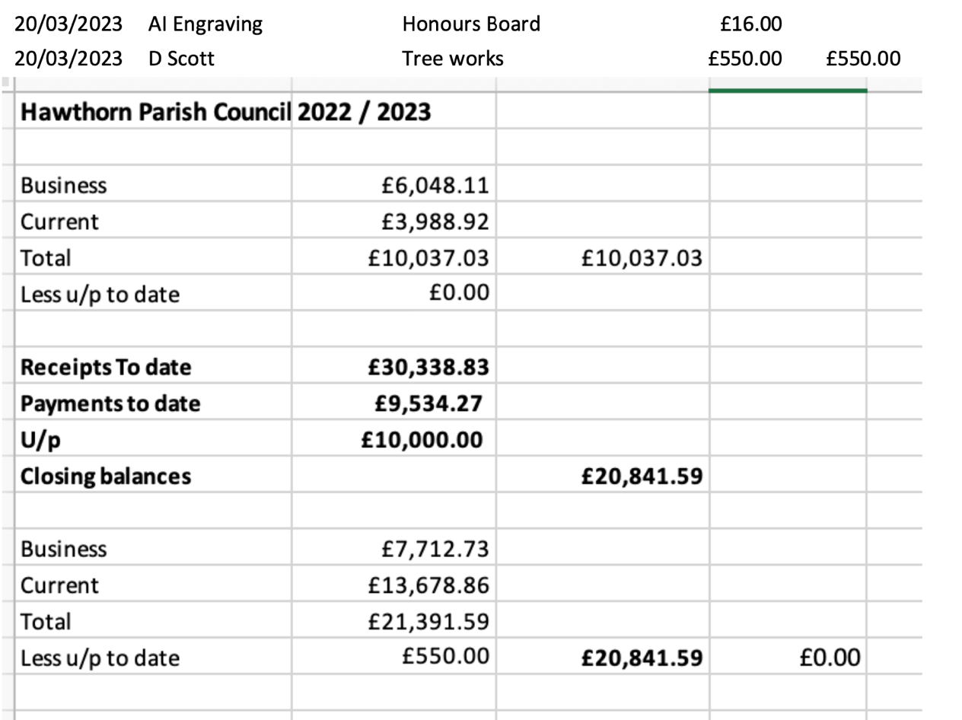

Plus
Cllr. Alan Askew - £50 - frames from Norman Hughes Award.

Changing bank accounts – Unity Bank information
The Clerk confirmed that she would attempt to change the bank accounts to Lloyds following receipt of the precept, members’ fund grant and vat. If a problem, then she suggested the Council consider moving to Unity Bank – although this will incur a monthly charge.
RESOLVED
To receive the information and discuss again at the April meeting.

Play Area

Fencing and Play Equipment
RESOLV ED
- To approve the schedule of works from Streetscape – apart from the new swings.
- All monies saved / remaining from the £9,700 grant to go towards the new fencing.
- To meet with Matthew Day from Streetscape on site to finalize details.

Training:
None

Planning: Current Planning applications
No new planning applications have been received.

Events & Information

Walking the footpaths
This continues to be delayed until the footpaths is usable.
Information has been received from DCC re the ROW on the footpath near the old Pemberton Arms
The contractor has said they plan to roll the path flat with a machine whilst filling in any deep ravines or holes along the way, they will then scatter stone on top and roll again to create a useable surface which should mirror the surface of the original path. A higher standard of surface will be laid in the future.
RESOLVED
- To receive the information.
- To continue to express concerns re public safety.

Spring Clean
The ~Clerk informed members that DCC will be dropping off the equipment etc.
Cllr Carolyn Winter to lead on the event – the Clerk has given all information to Cllr. Winter.

Coronation Community Event
RESOLVED
- To work with the Community Centre to provide entertainment - similar to those held last year for the Queens Platinum Jubilee.
- To give a donation of £250 to the Community Centre as the council’s contribution to the day.

Date of the next meeting:

Monthly Meeting
This will be held on Monday 17th April.

June Monthly Meeting
The Clerk informed members that she is away working at the time of the scheduled June meeting and suggested it be postponed for a week until June 26^{th.}
RESOLVED
To hold the June Monthly Meeting on Monday 26th June.

The Chairman thanked everyone for attending and closed the meeting at 8.25 pm.

