Hawthorn Parish Council
Clerk to the Council: Lesley Swinbank MBA, FSLCC
Springwell House, Spring Lane, Sedgefield Co. Durham. TS21 2HS
Tel. 01740 622429
Email: clerk@hawthornparish.co.uk

The Annual Meeting of the Hawthorn Parish Council will be held at 7pm on Monday May 19th 2025 in the Community Centre.

AGENDA

Election of Chairman

Acceptance of Office of Chairman

Apologies

Election of Vice Chairman

Election of a Grievance Committee

Election of an Appeals committee

Approval of the following which are available on the Parish Council website

Standing Orders

Financial Regulations

Delegation Scheme

Code of Conduct

Effectiveness of the Internal Auditor

Financial Risk Assessment

Election of representatives to outside bodies: -

County Durham Association AGM

Smaller Local Councils Committee

East Durham Local Council Committee

Other organisations

To re - affirm Hawthorn Parish Council meets the criteria to adopt the General Power of Competence
(Localism Act 2011 sections 1 -8, specifically s1(1)) as set out in the Parish Councils (General Power of Competence) (Prescribed Conditions) Order 2012.

To re-affirm the Council’s Code of Conduct

To re-affirm the Council’s commitment to its Civility and Respect Policy

Appointment of the Internal Auditor

This meeting will be followed by the May Monthly Meeting at approx. 7.15pm

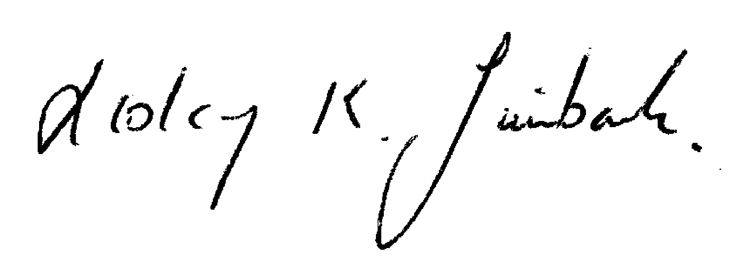
Lesley Swinbank
Parish Clerk:
1st May 2024

