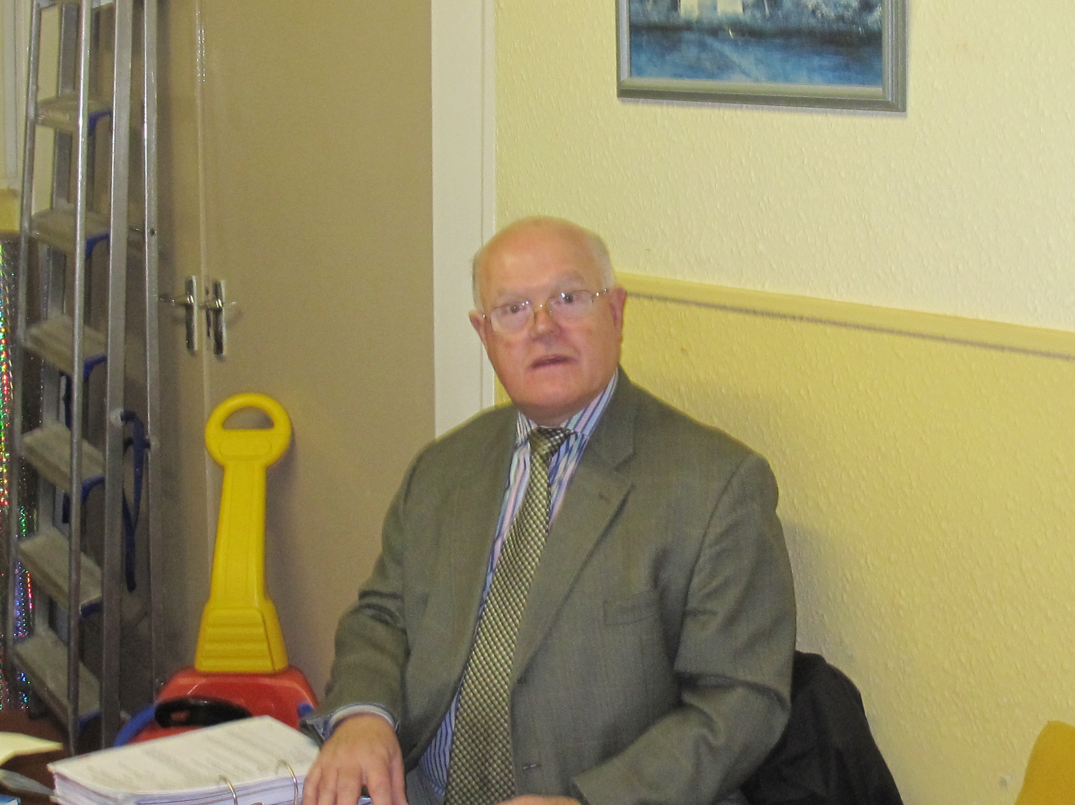 | Alan Askew (Chairman)  I have lived in Hawthorn all my life. It has been a great place to live, with fantastic walks, characters and scenery. It is such a perfect place to call my home.  I joined the parish council in 2010 and this allows me to make a positive contribution to the village and in particular to the community and the community centre.  I retired from the building industry some years
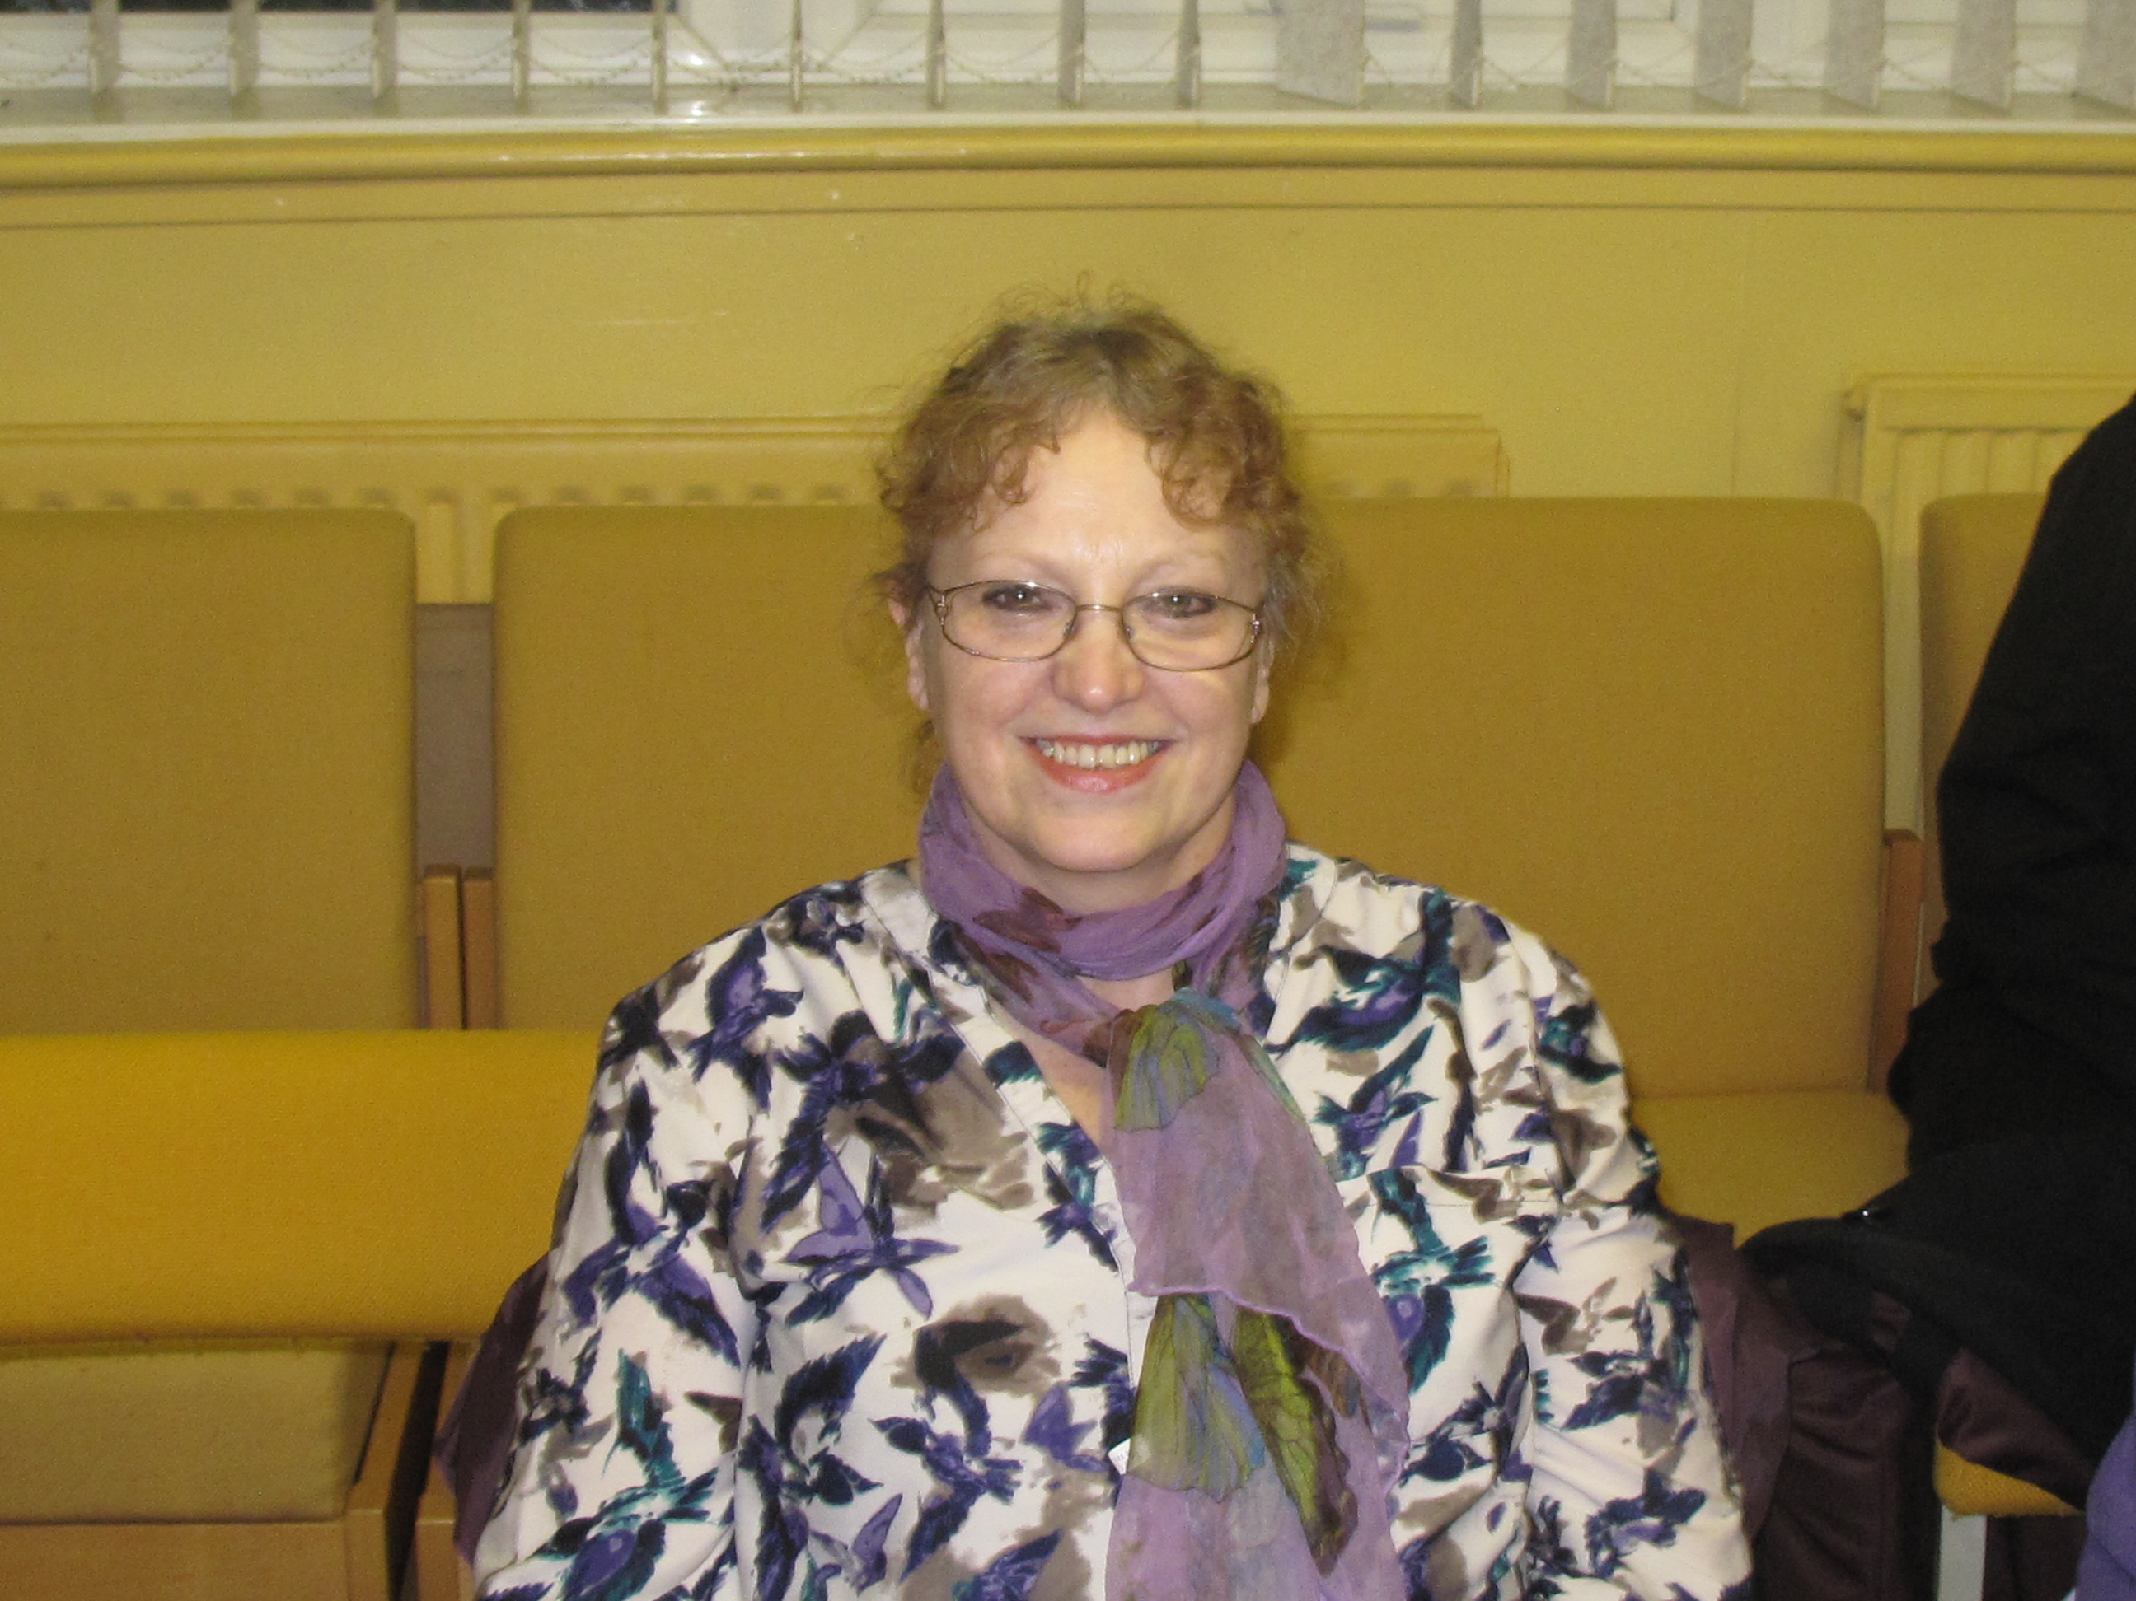 | Diane Hughes  I have lived in Hawthorn for the past 5 years. It’s been a great place to live with fantastic walks, a beautiful Dene and short walk to the coast. It’s a perfect place to call my home. I wish I had known about it many years ago. I joined Hawthorn Parish Council in 2014 and this allows me to make a positive contribution to the village and in particular to Christmas events. My special interest is that of people of the older generation.  I have managed The Village Nursing Home in Murton for the last 6 years and am now area manager to the rest of the group. Although I am a general trained nurse (RGN) I have specialised in Dementia and Mental Health. I take a lead in first aid training as well as other health related subjects. It is an honour to serve on the Parish Council and to help represent the people of Hawthorn.
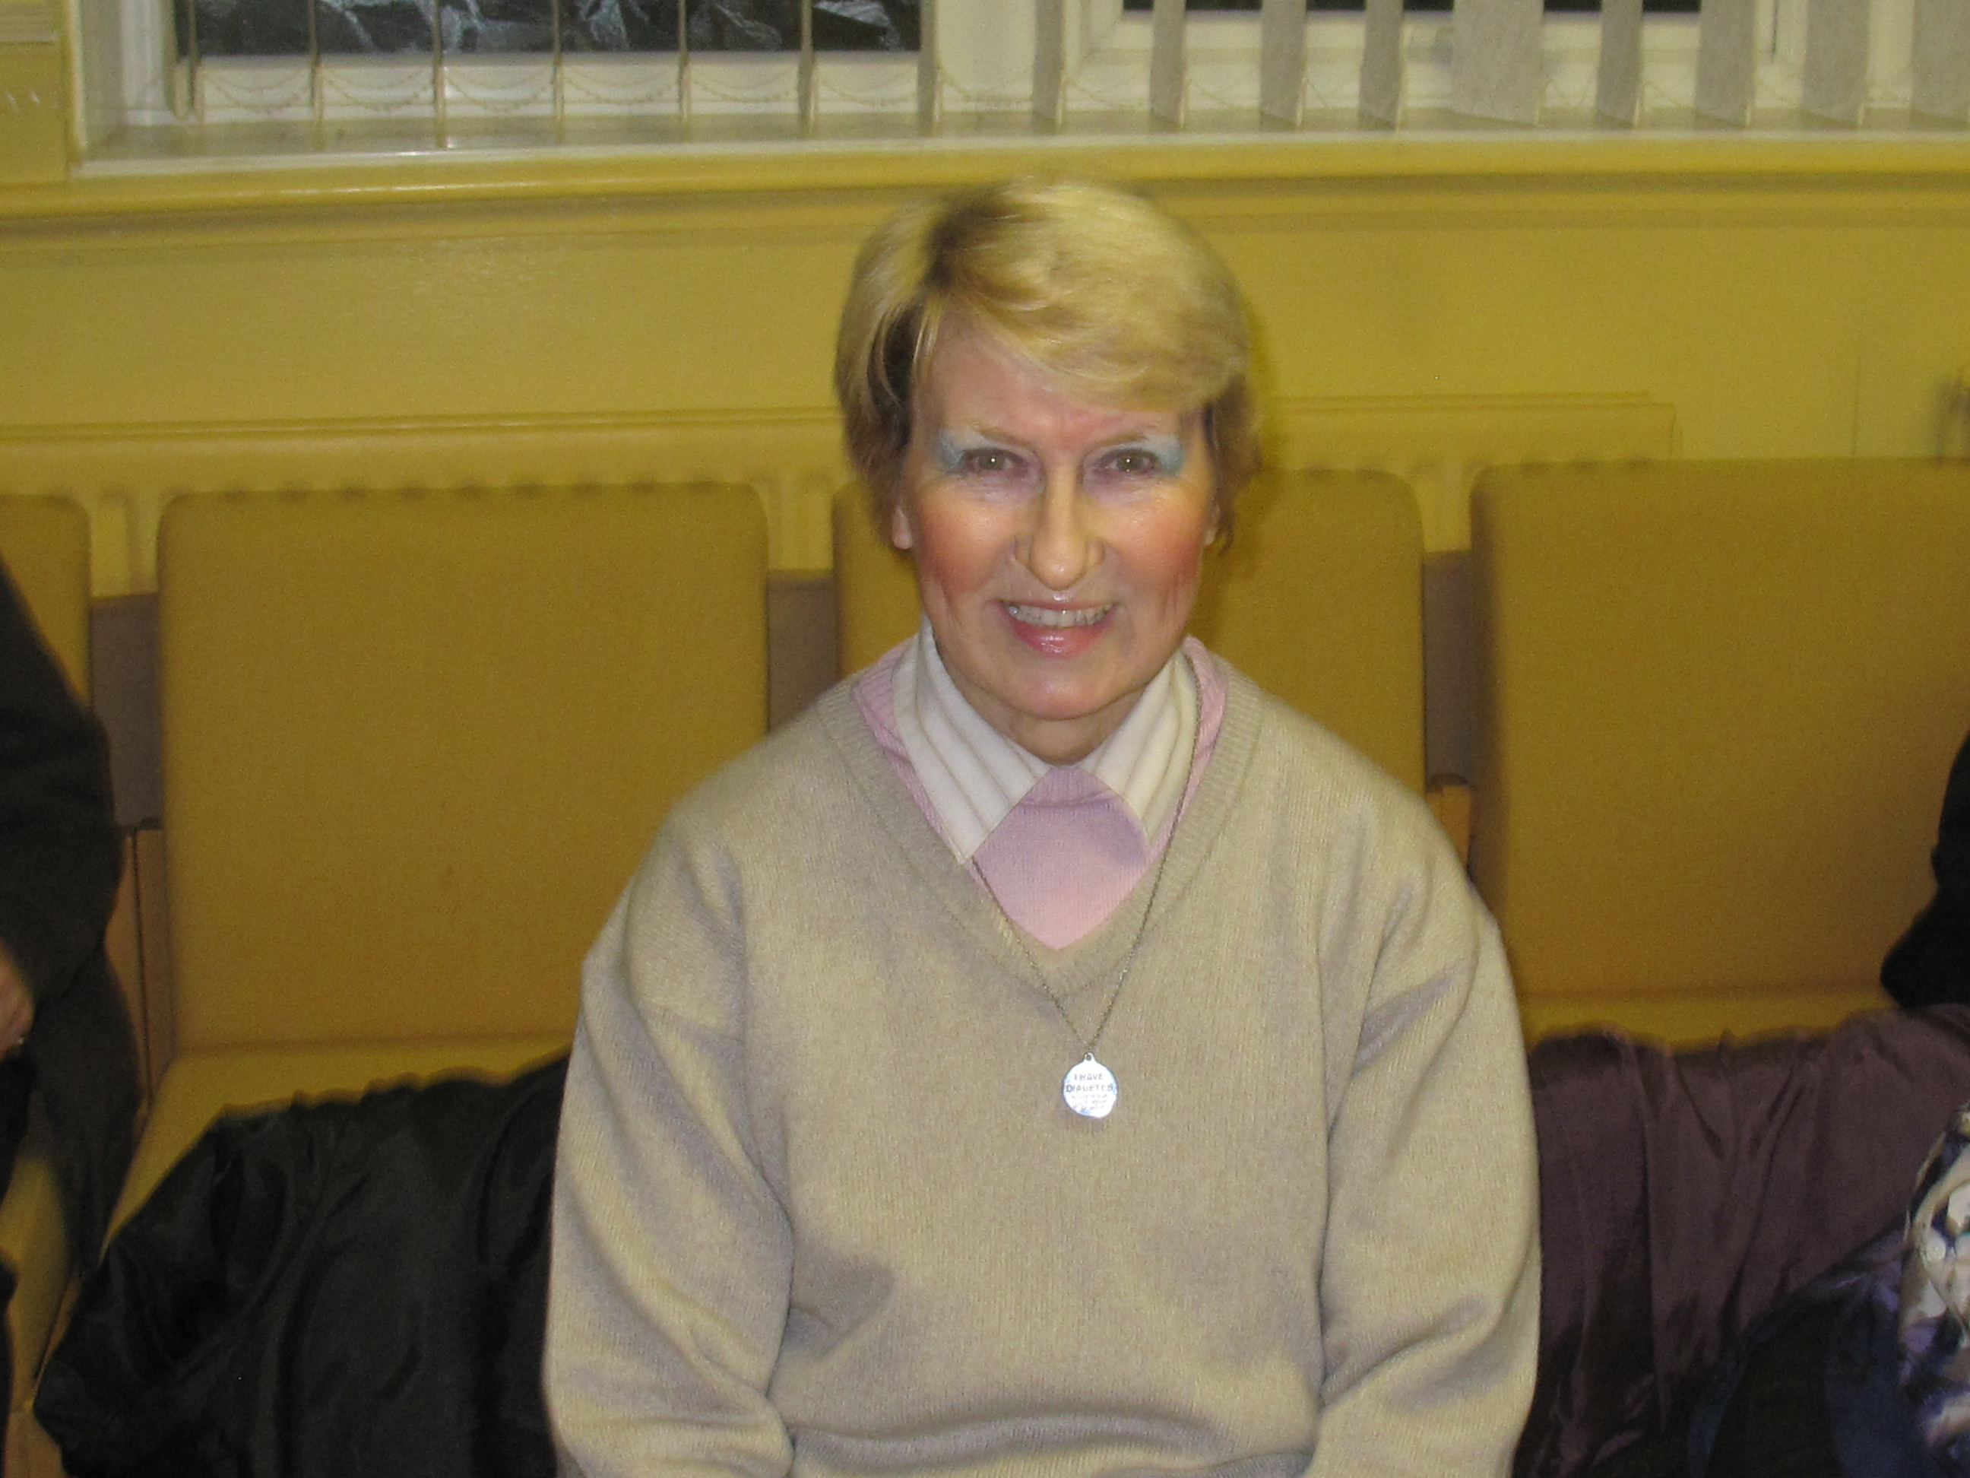 | Sheila Irving  I was born in Hawthorn and have lived in this picturesque village for all of my life. Over the last 50 years I have seen a number of changes in Hawthorn and joined the parish council in 2014.  Prior to retirement I worked at Caterpillar for 22 years. I find Hawthorn to be a delightful place to live, offering a scenic coastal route and pleasant seasonal walks throughout the Dene.
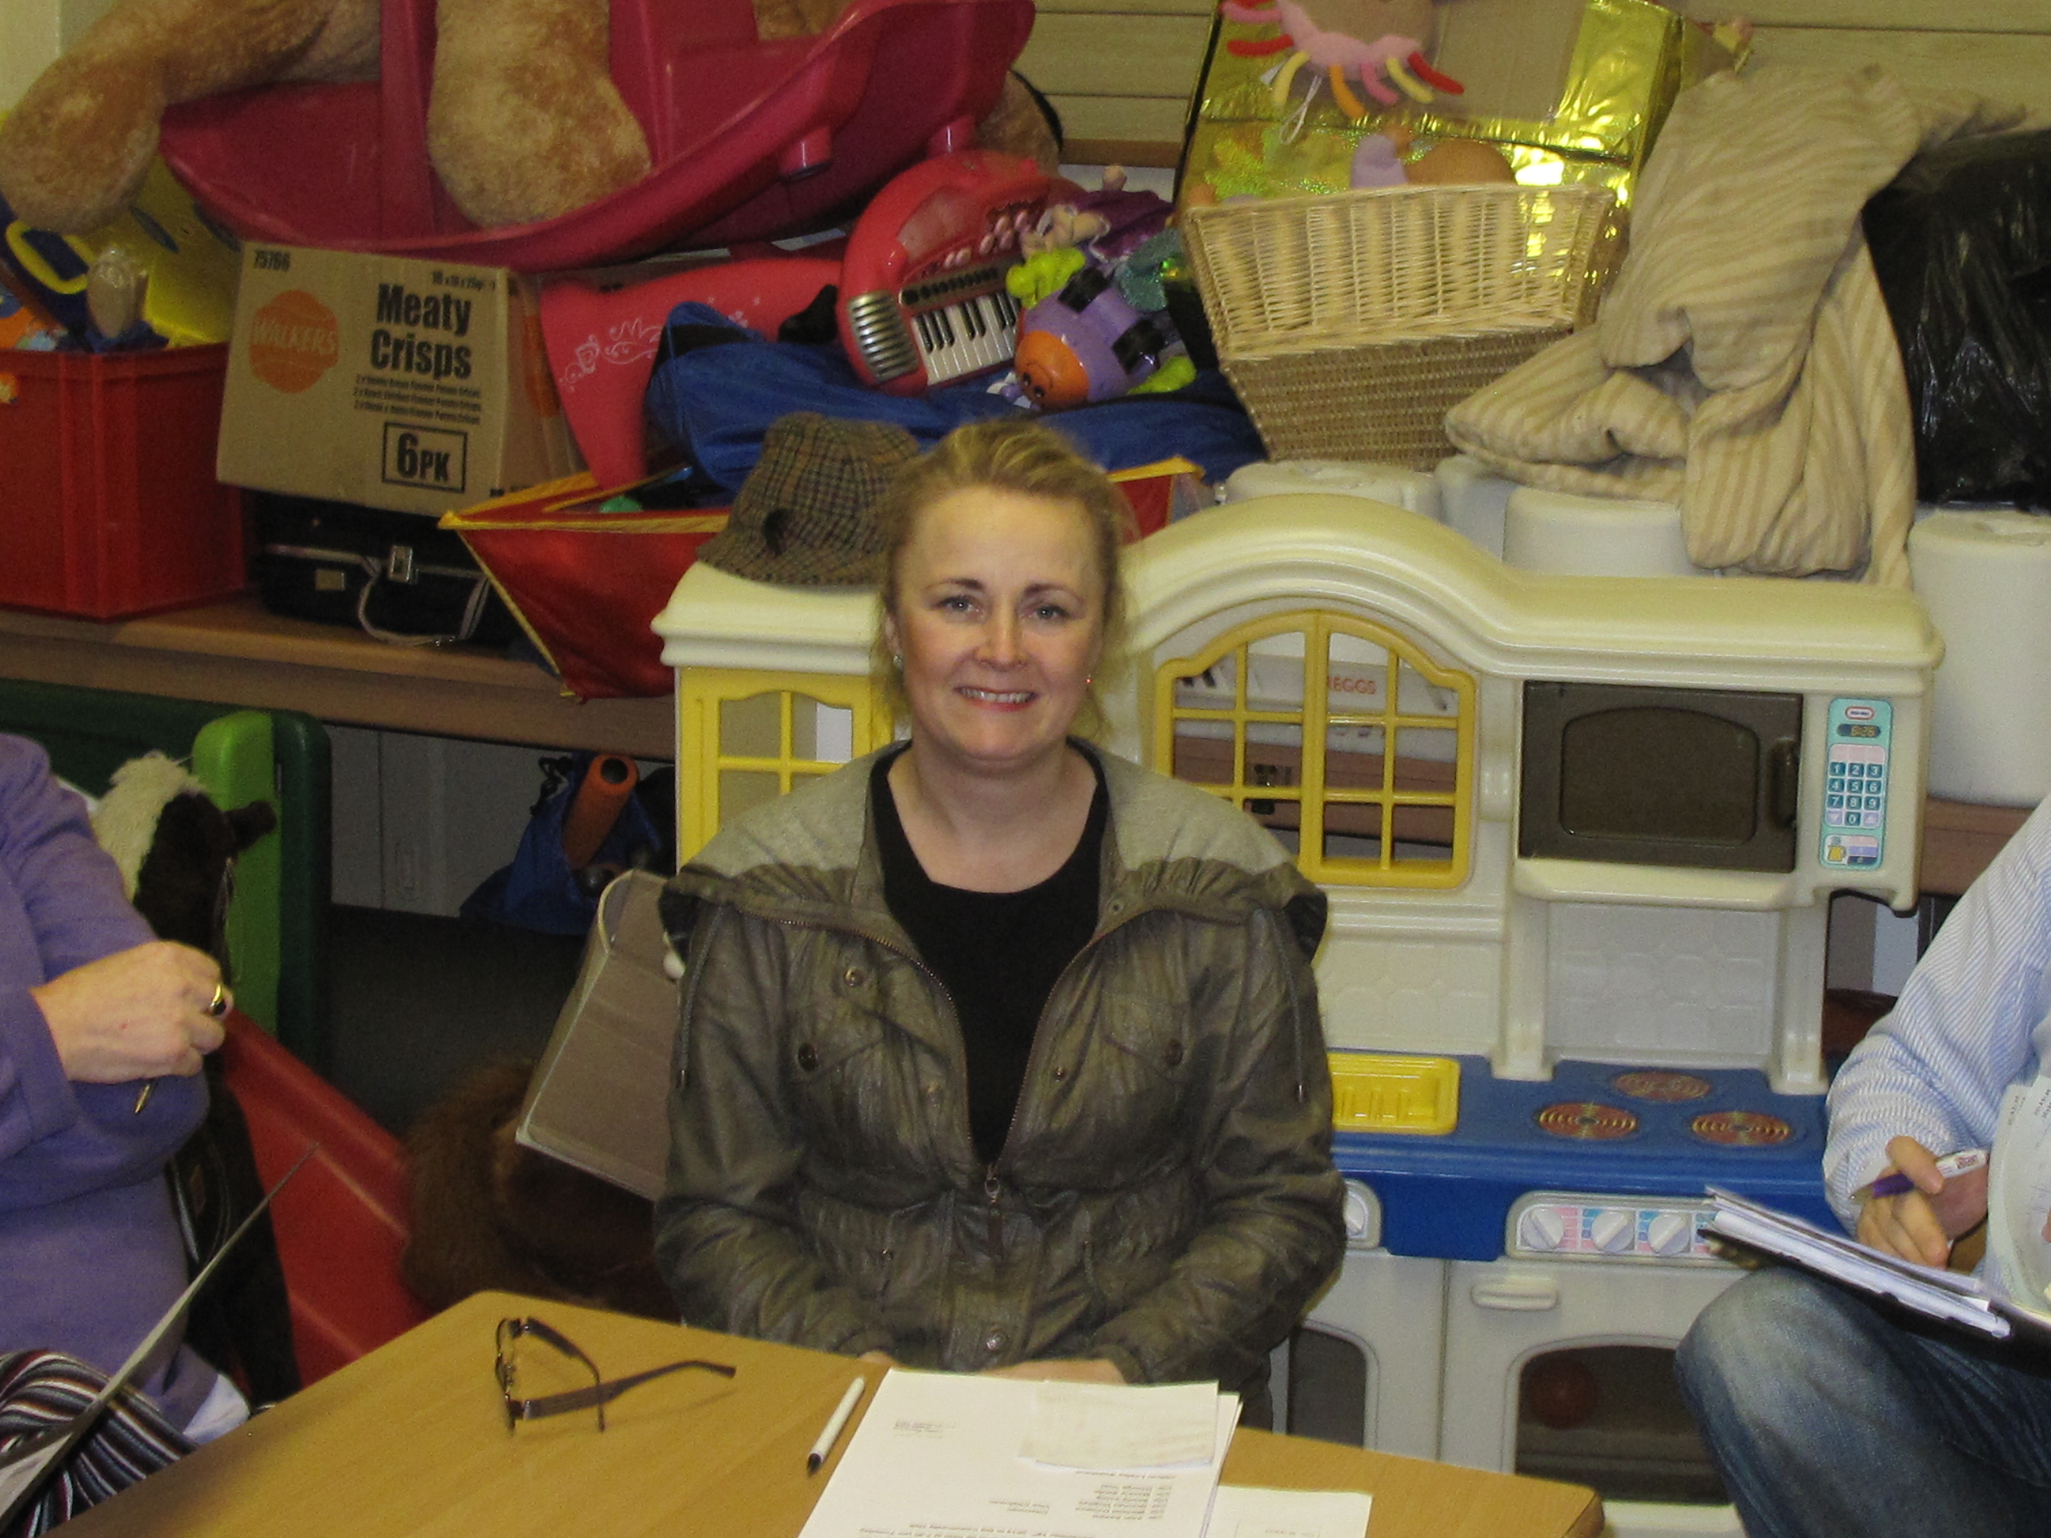 | Maxine Smith  I have lived in Hawthorn village for 15 years with my husband Ian and two children. It has been a lovely village for us all to live in with stunning scenery and the beautiful Dene.  I have worked as a hairdresser for over 30 years and a member of Hawthorn Parish Council for six years. I enjoy working and contributing to our village and the local community.
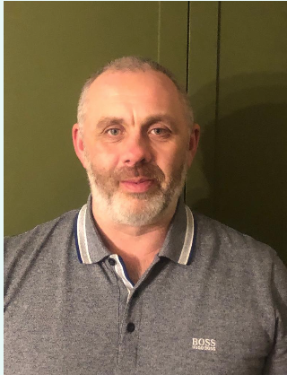 | Gary Thompson  I moved into the village with my family & dogs in 2021, because Hawthorn and it's beautiful surroundings are fantastic for walks. I am keen to embrace village life, to contribute and support the parish council, other organisations and residents.
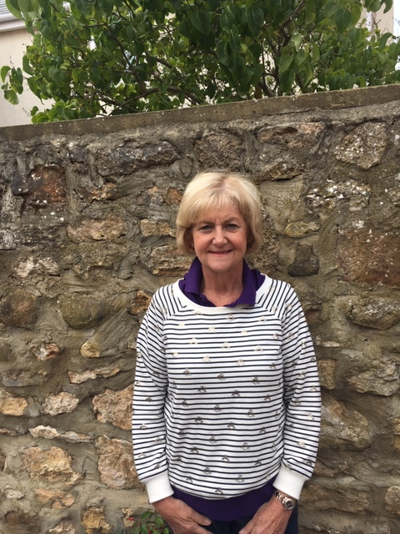 | Sheila Wilson  I have lived in Hawthorn for 17 years and really enjoy our village and the surrounding countryside.  I look forward to becoming part of the Parish Council and working towards improving the best interests for our Community
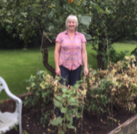 | Carolyn Winter  Carolyn has lived in Hawthorn for many years and has been involved in many community activities and events.

