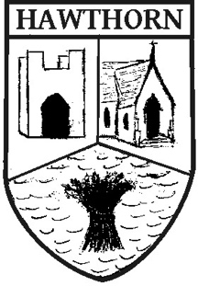 | Hawthorn Parish Council  Protocol: Public Participation  (Adopted by HPC: September 2019) | 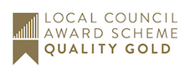

Introduction
Hawthorn Parish Council first adopted a protocol for public participation in 2014. This protocol, after review, forms the basis for this policy.

Background
This council meets and makes its decisions in public and is committed to community engagement and therefore warmly invites members of the public, the press, the police and county councillors to attend meetings and contribute within the public forum. A council meeting is not a public meeting, it is a meeting held in public and there is no requirement in law to provide a public forum but this council welcomes the opportunity to offer this facility.

The Policy
This Policy applies to: Participation in the Public Forum by members of the public
- Public participation is limited to electors or electors qualified in the electoral district of Hawthorn
- Public participation section will be for a maximum period of 15 minutes.
- The agenda will indicate when the public participation will take place. This will be early on in the agenda so that councillors may take into account any views expressed when reaching their decisions.
- Public participation is only permitted regarding items already on the agenda and the matter may be addressed immediately or carried forward without discussion.
- A maximum of three minutes is permitted for a member of the public to speak and only one person may speak on any agenda item excepting that two people may speak if opposing views are being expressed i.e. one for and one against a particular matter.
- Supplementary comment or question is solely at the discretion of the chairman.
- No question may be repeated within a 6-month period for that particular issue

