Hawthorn Parish Council
Clerk to the Council: Lesley Swinbank MBA, FSLCC
Springwell House, Spring Lane, Sedgefield Co. Durham. TS21 2HS
Tel. 01740 622429
Email: clerk@hawthornparish.co.uk

In accordance with Paragraphs 8 & 10(2) (b) of Schedule 12 of the Local Government Act 1972, I hereby summon you to attend a Meeting of HAWTHORN PARISH COUNCIL to be held in the COMMUNITY CENTRE HAWTHORN on MONDAY 17th JULY 2023 at 7pm

AGENDA

Notice of Meeting
Public Notice of the Meeting has been given in accordance with Sch 12 paragraph 10(2) of the LGA 1972

Apologies: To receive apologies and to approve reasons for absence

Declarations of Interest
To notify of any items that appear in the agenda in which you may have an interest, including those that have previously been recorded in the Members Register of Interests.

Ann Hitch : Recoup
Presentation on recycling.

Minutes:

To approve the Minutes of the Monthly Meeting held Monday 26th June 2023

Matters of Information

Reports

Police

DCC

Community Centre

Any other reports

Public Participation: Comments on items on this agenda

Correspondence

Reduction in LCTSG : CDALC

D Day Arrangements : Information from CDALC

Financial:

To endorse the monies paid by the Clerk since the last meeting / Bank reconciliation.

Changing bank accounts : Progress report

Daffodil Bulbs : To purchase

Training:

Trees on Village Green : Future works

Planning: Current Planning applications

Neighbourhood Watch Scheme : Update on information

Events & Information

Coronation Community Event

Switching on lights : Dec 2nd

Date of the next meeting: Monthly Meeting of the Council: Monday 18th September 2023
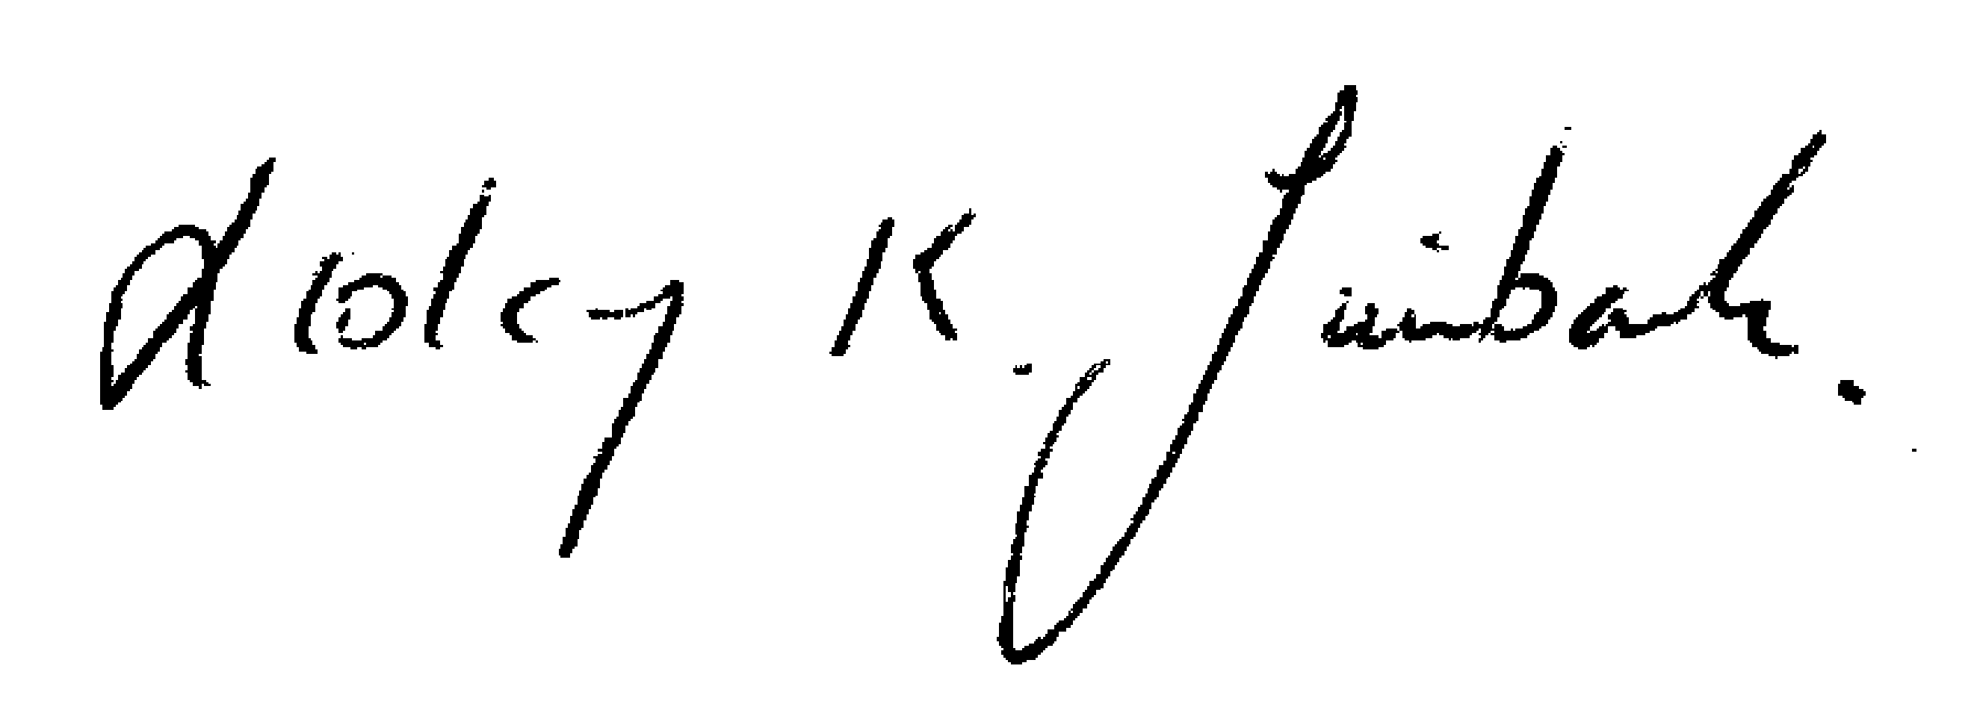

Lesley K. Swinbank (Parish Clerk):
10th July 2023
All residents and the press are welcome to come along to the meeting.

