Hawthorn Parish Council
Clerk to the Council: Lesley Swinbank MBA, FSLCC
Springwell House, Spring Lane, Sedgefield Co. Durham. TS21 2HS
Tel. 01740 622429
Email: clerk@hawthornparish.co.uk

You are summonsed to attend the Monthly Meeting of the Hawthorn Parish Council which will be held at 7pm on Monday 20th February 2023, in the Community Centre.

AGENDA

Notice of Meeting
Public Notice of the Meeting has been given in accordance with Sch 12 paragraph 10(2) of the LGA 1972

Apologies: To receive apologies and to approve reasons for absence

Declarations of Interest
To notify of any items that appear in the agenda in which you may have an interest, including those that have previously been recorded in the Members Register of Interests.

Minutes: To approve the Minutes of the Monthly Meeting held Monday 16th January 2023

Matters of Information: As per attached information sheet

Reports

Police

DCC

Community Centre

Annual Report

Norman Hughes Award

Any other reports

Public Participation: Comments on items on this agenda

Correspondence

Financial:

To endorse the monies paid by the Clerk since the last meeting / Bank reconciliation

Training:

Planning : Current Planning applications

Events & Information

Walking the footpaths

Spring Clean

Coronation Community Event

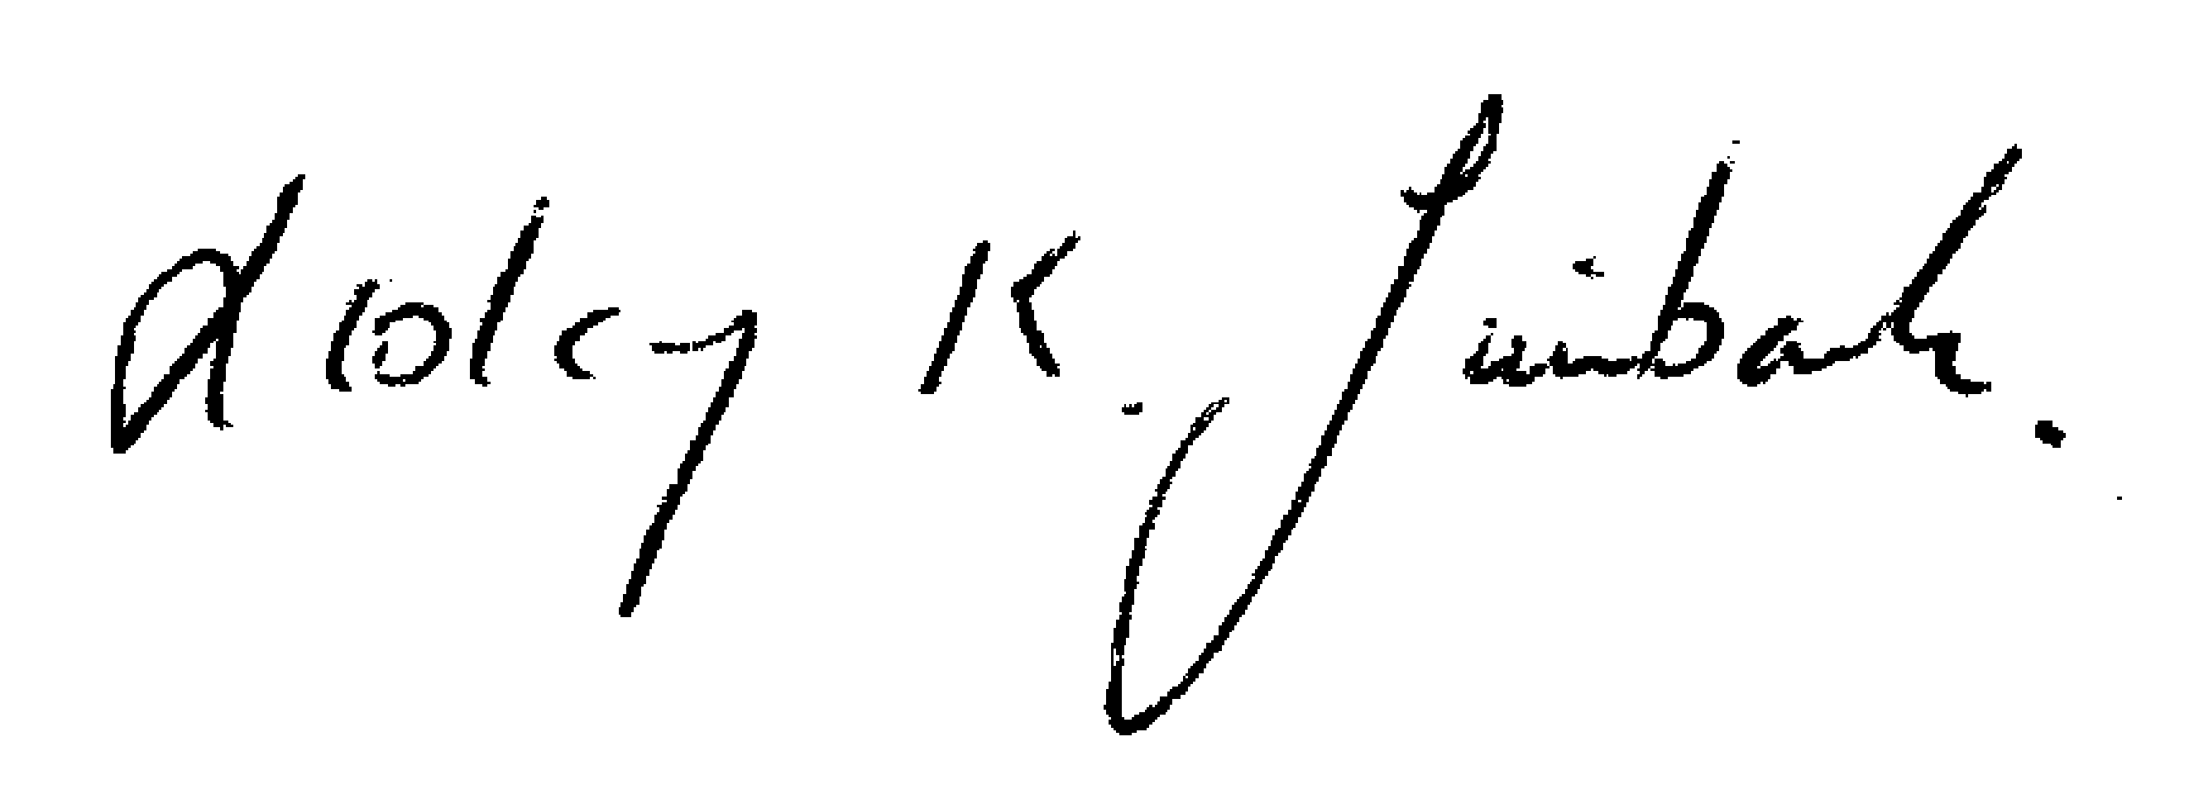
Date of the next meeting:

Annual Parish Meeting : Monday 20th March 2023 : 7pm

Monthly Meeting : Monday March 20th March following
Lesley K. Swinbank (Parish Clerk):
13th Feb 2023

All residents and the press are welcome to come along to the meeting.

